##### “QUIZ APPLICATION”



***A project report submitted to***

***Rajiv Gandhi Proudyogiki Vishwavidyalaya, Bhopal***

***in partial fulfillment for the award of***

***the degree of***

***Bachelor of Engineering***

***in***

***Computer Science & Engineering***

**DEPARTMENT OF COMPUTER SCIENCE & ENGINEERING**

**SUSHILA DEVI BANSAL COLLEGE OF TECHNOLOGY**

**INDORE- 453331**

**2019**

##### “QUIZ APPLICATION”



***A project report submitted to***

***Rajiv Gandhi Proudyogiki Vishwavidyalaya, Bhopal***

***in partial fulfillment for the award of***

***the degree of***

***Bachelor of Engineering***

***in***

***Computer Science & Engineering***

**PROJECT GUIDE SUBMITTED BY**

**Ms. Sameeksha Khandelwal Bhumika Kanojia (0829CS161033)**

**Durgesh Mishra (0829CS161043)**

**Harsh Verma (0829CS161048)**

**DEPARTMENT OF COMPUTER SCIENCE & ENGINEERING**

SUSHILA DEVI BANSAL COLLEGE OF TECHNOLOGY

**INDORE- 453331**

**2019**

**ACKNOWLEDGEMENT**

We have taken efforts in this project. However, it would not have been possible without the kind support and help of many individuals and organizations. We would like to extend my sincere thanks to all of them.

We are highly indebted to **Sushila Devi Bansal college of Technology, Department of “Computer Science and Engineering”** for their guidance and constant supervision as well as for providing necessary information regarding the project & also for their support in completing the project.

We would like to express our gratitude towards the guidance of **Ms. Sameeksha Khandelwal** & Faculty member for their kind co-operation and encouragement which help us in completion of this project.

We would like to express my special gratitude and thanks to my team mates without team work the project was out of bound.

Our thanks and appreciations also go to my colleague in developing the project and people who have willingly helped me out with their abilities.

**Bhumika Kanojia (0829CS161033)**

**Durgesh Mishra (0829CS161043)**

**Harsh Verma (0829CS161048)**

SUSHILA DEVI BANSAL COLLEGE OF TECHNOLOGY

**INDORE, 453331**



**CERTIFICATE**

This is to certify that **Bhumika Kanojia (0829CS161033), Durgesh Mishra (0829CS161043), Harsh Verma (0829CS161048)** have completed their project work, titled **“QUIZ APPLICATION”** as per the syllabus and have submitted a satisfactory report on this project as a part of fulfillment towards the degree of **“BACHELOR OF ENGINEERING” (Computer Science & Engineering)**  from **RAJIV GANDHI PROUDYOGIKI VISHWAVIDYALAYA, BHOPAL.**

**HEAD OF THE DEPARTMENT PROJECT GUIDE**

**DIRECTOR**

SUSHILA DEVI BANSAL COLLEGE OF TECHNOLOGY

**INDORE, 453331**



**CERTIFICATE**

This is to certify that **Bhumika Kanojia (0829CS161033), Durgesh Mishra(0829CS161043), Harsh Verma(0829CS161048)**have completed their project work, titled **“QUIZ APPLICATION”** as per the syllabus and have submitted a satisfactory report on this project as a part of fulfillment towards the degree of **“BACHELOR OF ENGINEERING” (Computer Science & Engineering)**  from **RAJIV GANDHI PROUDYOGIKI VISHWAVIDYALAYA, BHOPAL.**

**INTERNAL EXAMINER EXTERNAL EXAMINER**

**TABLES OF CONTENTS**

**CHAPTER No. TITLE PAGE NO.**

**ABSTRACT i**

**LIST OF TABLES ii**

**LIST OF FIGURES iii**

**CHAPTER 1. INTRODUCTION**

1.1 Purpose 1

1.2 Scope 1 1.3 Problem Definition 2  
 1.4 Proposed solution 3

**CHAPTER 2. SYSTEM REQUIREMENT ANALYSIS**

2.1 Overall Description 4 2.1.1 Product Perspective 4

2.1.2 Product Function 4

2.1.3 User Classes And Characteristics 5

2.1.4 Operating Environment 5

2.1.5 Design And Implementation Constraints 5

2.1.6 Assumptions And Dependencies 5

2.2 External Interface Requirement 6  
 2.2.1 User Interfaces 6

2.2.2 Hardware Interfaces 7

2.2.3 Software Interfaces 8

2.2.4 Communications Interfaces 8

2.3 Functional Requirement 8

2.3.1 System Feature 8

2.4 Non Functional Requirement 9

2.4.1 Performance Requirement 9

2.4.2 Safety Requirement 9

2.4.3 Security Requirement 9

2.5 Project Plan 10

2.5.1 Team Members 10

2.5.2 Division Of Work 10

2.5.3 Time Schedule 10

**CHAPTER 3. ANALYSIS**

3.1 Methodology Used 11

3.2 Use Case Diagram 13

3.3 Sequence Diagram 17

3.4 Activity Diagram 21

3.5 Class Diagram 24

3.6 Data Flow diagram 25

**CHAPTER 4. DESIGN**

4.1 Architectural Design 26

4.1.1 System Architectural Design 26

4.1.2 Description Of Architectural Design 26

4.2 Database Design 28

4.2.1 Normalization 28

4.3 Component Design 29

4.3.1 Flow Chart 29

4.4 Interface Design 30

4.4.1 Screenshots 30

**CHAPTER 5. IMPLEMENTATION**

5.1 Language And Database System Used 36

5.2 Features Of Language And Database Used 36

5.3 Description Of Third party tools Used 36

**CHAPTER 6. TESTING**

6.1 White Box Testing 37

6.2 Black Box Testing 38

**CHAPTER 7. FUTURE SCOPE AND LIMITATION 39**

**CHAPTER 8. CONCLUSION 40**

**CHAPTER 9. REFERENCE 41**

**ABSTRACT**

The project: “**Quiz Application**” is a collection of number of different types of quizzes like technical, games, sports, etc. A user can access/play all of the quiz and can attempt any of the one. There will be limited number of questions and for each correct answer user will get a credit score. User can see answers as well as can ask a query related to it. There are many quiz applications available currently on internet. But there are few Which provide better understanding between users and the application like, providing proper answers, user query solving, uploading user questions as well as answer to it, etc. To develop a user friendly quiz application which will contain : Numbers of quiz , Answers to every question, Query solving regarding any question, Uploading of user question and answer , and to improve the knowledge level of users. To develop a application which will contain solution to the above problems. By this application the user will come to know about his/her level and can learn additional knowledge. Also by this application a user can expand his/her knowledge among the world.

**LIST OF TABLES**

**Table no. Title Page no.**

2.1.4.1 Operating Environment 5

2.2.2.1 Hardware Interfaces 7

2.2.3.1 Software Interfaces 8

3.2.1 Use case specification for Registration 14

3.2.2 Use case specification for Log-In 14

3.2.3 Use case specification for Home Page 15

3.2.4 Use case specification for Admin Home Page 15

3.2.5 Use case specification for Result 16

3.2.6 Use case specification for Log-Out 16

4.2.1.1 Normalization database table 28

**LIST OF FIGURES**

**Figures no. Title Page no.**

2.2.1.1 Login Page 6

2.2.1.2 Registration Page 7

3.1.1 Waterfall life cycle Model 12

3.2.1 Use Case Diagram 13

3.3.1 Sequence Diagram for Login 17

3.3.2 Sequence Diagram for play Quiz 18

3.3.3 Sequence Diagram for Submit Question 19

3.3.4 Sequence Diagram for Logout 20

3.4.1 Activity Diagram for Login 21

3.4.2 Activity Diagram for Submit Quiz 22

3.4.3 Activity diagram for Play Quiz 23

3.5.1 Class Diagram for Quiz Application 24

3.6.1 Data Flow Diagram for Quiz application 25

4.1.2.1 A 3-Tier Architecture diagram 26

4.3.1.1 Flow Chart for Quiz Application 29

4.4.1.1 Screenshot for Home Page 30

4.4.1.2 Screenshot for About Quiz Page 31

4.4.1.3 Screenshot for Registration 31

4.4.1.4 Screenshot for Login page 32

4.4.1.5 Screenshot for Forgot Password 32

4.4.1.6 Screenshot for Admin Page 33

4.4.1.7 Screenshot for Submit Question Page 33

4.4.1.8 Screenshot for User Home Page 34

4.4.1.9 Screenshot for Attempting Quiz Page 34

4.4.1.10 Screenshot for Result Page 35

4.4.1.11 Screenshot for Feedback Page 35

6.2.1 Diagram for Black Box Testing 38

1. **INTRODUCTION**
   1. **Purpose**

This web application provides facility to Play online quiz and practice Grammar, Aptitude, and G.K. It provides a good platform, where a student not only judges there knowledge/skill but also they can improve knowledge/skill at the same time.

* 1. **Scope**

**The Scope of this project is very broad in terms of gaining knowledge and sharing knowledge among world.**

Few points are:-

* Can be used anywhere any time as it is a web based application.
* This application will be used in educational institutions as well as in corporate world.
  1. **Problem Definition**

**“Our aim is to develop a application for the users in which a user can attempt any number of quiz related to his/her choice.”**

Firstly, we have to make interfaces for Home Page, Registration, Login Page, Questions Attempting forum, Result Page, & Profile of user. These all pages have connectivity with the server and database. So, that it can work properly. Currently, there are websites which only provide limited number of quizzes related to different domain. Many websites do not have a single platform for quizzes related to technical, G.K, Aptitude, Games, etc. And there is not a website where the users can upload his/her questions and answers for the others. We have to develop a

application which can resolve all of the above problems. By this user can gain knowledge, can solve his/her query, and spread his/her knowledge among the world.

* 1. **Proposed Solution**

The main requirement of application is to find questions and answers. In this application firstly the user need to register or login using user-id and password. Then the user can choose any of the quiz of his/her choice. Before starting the quiz there is a instruction window in which there are instruction related to attempt the quiz. After it user can start attaining the quiz. Here user can see his/her answers are right or wrong and can also see the answer of each. If there is any query related to it user can ask it. After completion of the quiz user will get credit score for each of its correct answers. Initially the questions are given by the admin but after sometime the user itself can submit questions and its answers. After verification by the admin the questions are shown on the window. The query related to a question can we solved by admin as well as the users of this application. This application initially contain admit and some higher prior user which can submit question and answers. The user profile will contain its name, age, qualification, gender, mobile number, credit score, etc. This application will provide link to additional useful website for learning purpose.

1. **SYSTEM REQUIREMENT ANALYSIS**

2.1 Overall Description-

2.1.2 Product Prespective

It is a quiz application which is based on web application. It usually interacts with user and students. Mainly it is quiz application in which there are 4 categories. Individual category will held 10 questions, and each question carries 1 mark. There is no negative marking. If we do not attempt any question then it will show “not attempted” mark.

In result screen, it will show total marks obtain in quiz, wrong answer will also been shown with correct answer.

Main purpose of this application is to develop knowledge and skills in students and user.

**2.1.2 Product Function**

Account login: Student/user can login using login id and password.

Account logout: Student/user can logout the account whenever required.

Result: Student/user attempted the quiz and gets a result.

Feedback: Student/user can give a feedback.

Play quiz: Student/user can play the quiz according to his/her choice.

Add Questions: Admin can add the question by selecting the topic.

**2.1.3 User Classes And Characteristics**

Users of the product must possess a minimal level. Users must know how to access the functionality of this system and get benefited.

**2.1.4 Operating Environment**

|  |  |  |
| --- | --- | --- |
| **S.NO.** | **NAME** | **HARDWARE** |
| 1. | Processor | Intel dual core(32 bit) |
| 2. | RAM | 2 GB |
| 3. | Processor Speed | 2GHz |

Table 2.1.4.1 Operating Environment

**2.1.5 Design And Implementation Constraints**

* Language of choice: JAVA.
* Platform for deployment: NETBEANS.
* Database: MySQL.

**2.1.6 Assumptions And Dependencies**

We assume that the users of our website should have a minimal knowledge of computer system and should have an availability of

internet. We are dependent on the sources from where we have

gathered the data and the data are authenticated.

**2.2 Enternal interface Requirements**

**2.2.1 User Interfaces**

The Admin has the access to overall control the functionalities of the system. The platform users i.e., admin student/user will be protected by login and password since; the platform allows the users to make some changes that can have propagating effects in the system. They can upload their updates and details in the system.

**Login Page:**

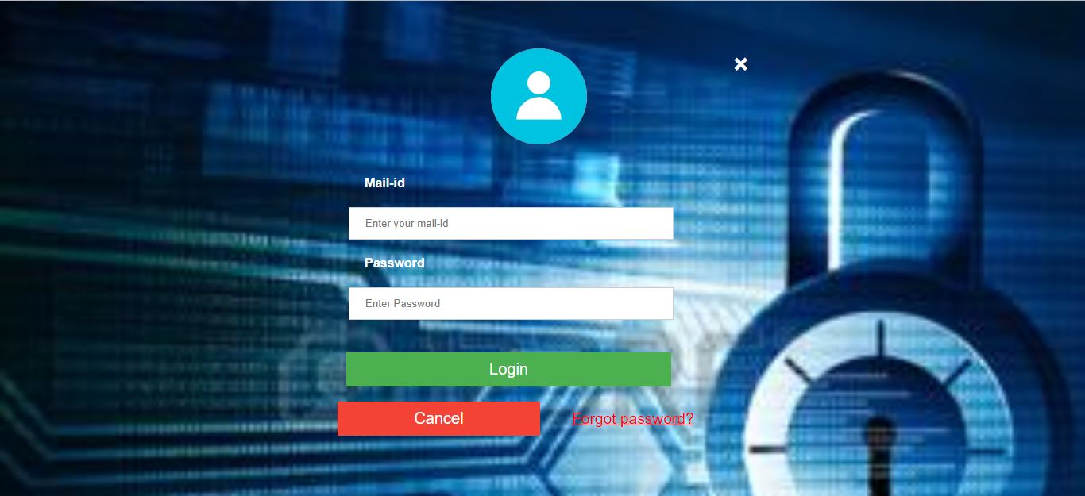

Fig: 2.2.1.1 Login

**Registration page:**

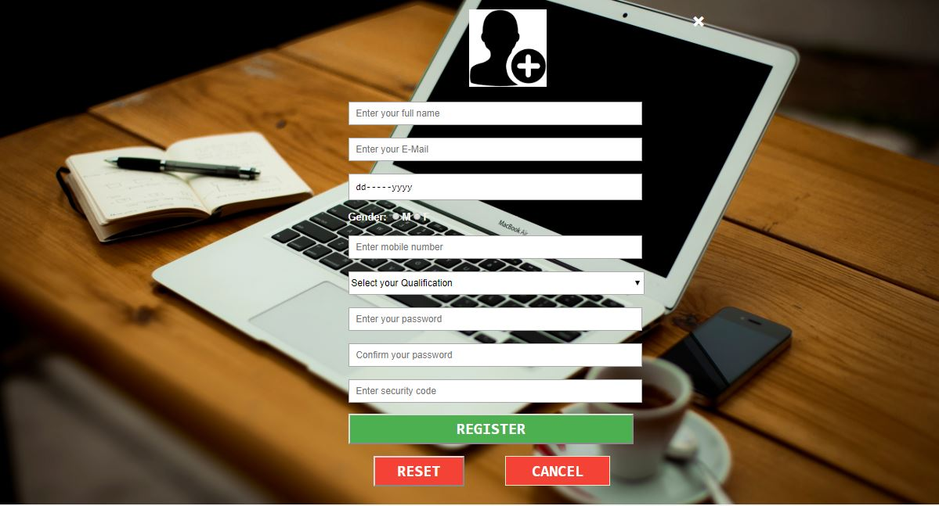

Fig : 2.2.1.2 Registration page

**2.2.2 Hardware Interfaces**

|  |  |  |
| --- | --- | --- |
| **S.NO.** | **NAME** | **HARDWARE** |
| 1. | Processor | Intel dual core(32bit) |
| 2. | RAM | 2 GB |
| 3. | Processor Speed | 2 GHz |

Table 2.2.2.1 Hardware Interfaces

2.2.3 Software Interfaces

|  |  |  |
| --- | --- | --- |
| **S. No** | **NAME** | **SOFTWARE** |
| **1** | Platform | Windows 7 |
| **2** | Database tool | MySql |

Table 2.2.3.1 Software Interfaces

2.2.4 Communications Interfaces

* Windows

**2.3 Functional Requriement**

**2.3.1 System Feature**

This section gives a functional requirement that applicable to the online exam system.

There are three modules in this phase:

1. Student/user module.
2. Admin module.

Functionality of each module are:

**Student/user module:**

The student/user have to login in application. They can choose any of the given quiz. Then the student/user will get result immediately after the completion of test.

## Admin module:

The admin can see all the tables in the Database and can add the question by selecting the particular topic.

**2.4 Non Functional Requriemet**

* + 1. **Performance Requirements**

**1. Response Time-**

The system shall give responses in 2 sec after user login.

**2. Capacity-**

The system can support multiple computer but it need to be install on every computer separately.

* + 1. **Safety Requirements**

All logged information, updates, user activities are securely stored.

**2.4.3 Security Requirement**

Any modification for the Database shall be synchronized and done by system admin.

2.5 Project Plan

2.5.1 Team Members

Name: Harsh Verma

Email:[harshverm776@gmail.com](mailto:harshverm776@gmail.com)

Name: Durgesh Mishra

Email: [durgeshmishra1999@gmail.com](mailto:durgeshmishra1999@gmail.com)

Name: BhumikaKanojia

Email: [bhumika.kanojia1@gmail.com](mailto:bhumika.kanojia1@gmail.com)

**2.5.2 Division of Work**

***“A team is on success gate if every individual is loyal to his/her***

***responsibility.”***

***Harsh Verma***: Front End, Back End, UML Diagram, Database Management.  
***Durgesh Mishra****:* Front End, Back End, Session Management, Database Connectivity.

***Bhumika Kanojia*:** Front End, UML Diagram, Documentation.

* + 1. **Time Schedule**

**1**. **Requirement Analysis**: Approximately 15 days

**2**. **Design** : Approximately 25 days

**3**. **Coding** : Approximately 30 days

**4**. **Testing** : Approximately 10 days

**3 ANALYSIS**

**3.1 Methodology Used**

The programming language used for the development of the project is JAVA and the software model used is the classic lifecycle model.

*Waterfall Process model*

The Classical Life Cycle or waterfall Process Model was the first process model to present a sequential framework, describing basic stages that are mandatory for a successful software development model. It formed the basis for most software development standards and consists of the following phases: Requirement analysis, design, coding, testing, and maintenance.

Advantages of waterfall model:

* Simple goal.
* Simple to understand and use.
* Clearly defined stages.
* Easy to arrange tasks.
* Process and result are well documented.
* Customers / end users already know about it.
* Easy to manage.

Disadvantage of Waterfall model:

* Rigid design and inflexible procedure.
* Waterfall model faced “Inflexible point solution” which meant even small amendments in the design were difficult to incorporate later design phase.
* As the requirement were froze before moving to the design phase, using the incomplete set of requirement,a complete design was worked amendments In case of a large project, completing a phase and then moving back to reconstruct the same phase, incurred a large overhead.
* Once a phase is done, it is not repeated again that is movement in the waterfall goes one to the next and the vice versa is not supported, deadlines are difficult to meet I case of large projects.

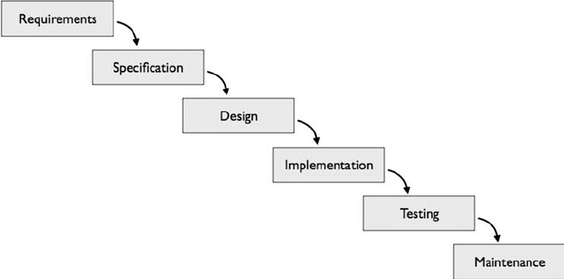

Fig. 3.1.1 Waterfall life Cycle model

**3.2 USECASE DIAGRAM**

1. USECASE DIAGRAM  
   A use case diagram at its simplest is a representation of user’s interaction with the system that shows the relationship between the user and the different use case in which the users is involved. A use case diagram can identify the different types of user of a system and the different use cases.

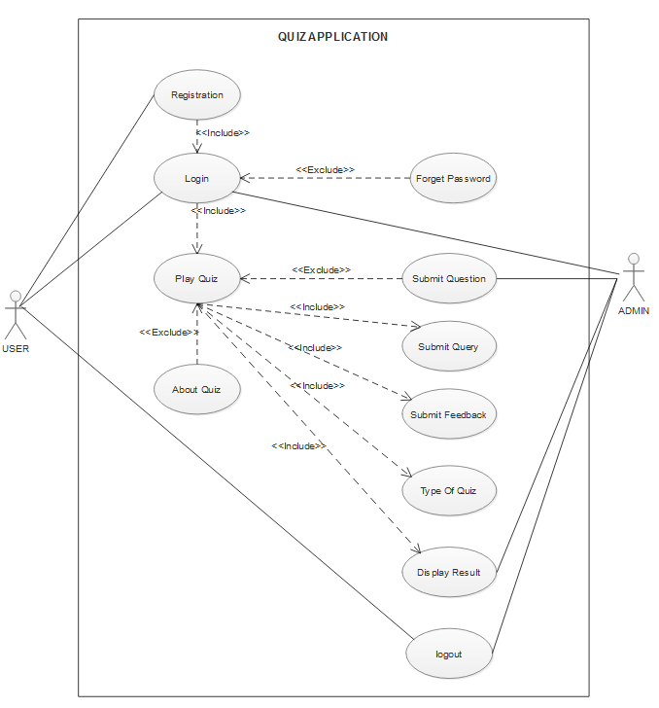

Fig: 3.2.1 Use Case

1. USE CASE SPECIFICATION

|  |  |
| --- | --- |
| Name of the use case | Registration |
| Actor | User/student |
| Precondition | None |
| Primary flow of events | Email id, password, dob, mobile no., Security code. |
| Alternate flow of events | If email, password, dob, mobile no. is wrong shows message “incorrect the some details”. |
| Post condition | If successful register and come to log in page. |
| Use case termination | Cancel |

Table 3.2.1 Use Case Specification for Registration

|  |  |
| --- | --- |
| Name of the use case | Log-In |
| Actor | User/student |
| Precondition | None |
| Primary flow of events | Email id , password |
| Alternate flow of events | If username or password is wrong shows message “incorrect email id and password”. |
| Post condition | If successful log and come to home page. |
| Use case termination | Cancel |

Table 3.2.2 Use Case Specification for Log – In

|  |  |
| --- | --- |
| Name of the use case | Home page |
| Actor | User/student |
| Precondition | Login Successfully |
| Primary flow of events | Can Access any of the given quizzes. |
| Alternate flow of events | None. |
| Post condition | Will Attempt Quiz. |
| Use case termination | Cancel |

Table 3.2.3 Use Case Specification for Home Page

|  |  |
| --- | --- |
| Name of the use case | Home page |
| Actor | Admin |
| Precondition | Login Successfully. |
| Primary flow of events | Can Submit question and can see any of the Database. |
| Alternate flow of events | None. |
| Post condition | None. |
| Use case termination | Cancel |

Table 3.2.4Use Case Specification for Admin Home Page

|  |  |
| --- | --- |
| Name of the use case | Result page |
| Actor | User/student |
| Precondition | Submit quiz. |
| Primary flow of events | Can see result. |
| Alternate flow of events | None. |
| Post condition | Can give feedback and go back to Home Page. |
| Use case termination | Cancel |

Table 3.2.5 Use Case Specification of Result

|  |  |
| --- | --- |
| Name of the use case | Logout |
| Actor | User/student |
| Precondition | Successful log in to the account |
| Primary flow of events | No primary flow. |
| Alternate flow of events | Session expired. |
| Post condition | User will be redirected to application home page. |
| Use case termination | Cancel |

Table 3.2.6 Use Case Specification for Logout

**3.3 SEQUENCE DIAGRAM**

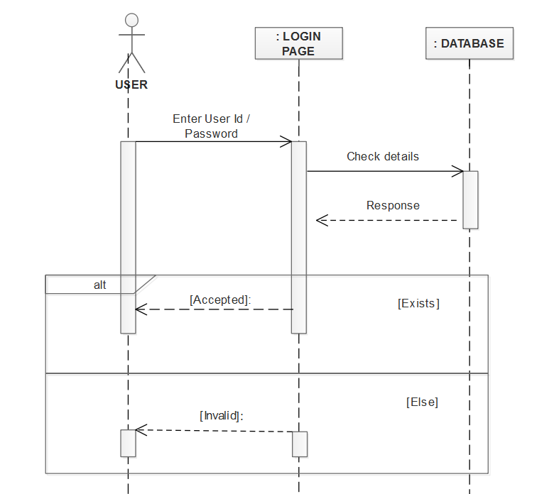

Fig: 3.3.1 Sequence Diagram For Login

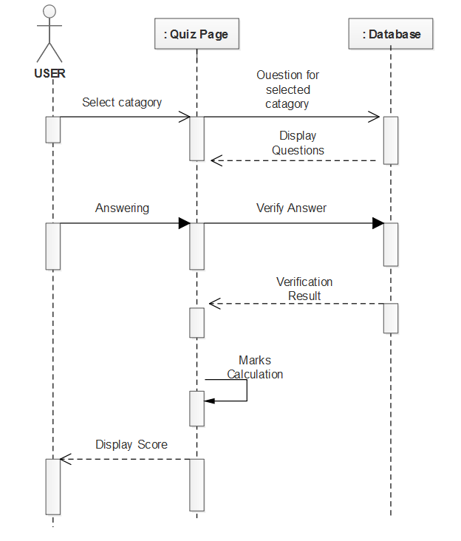 Fig : 3.3.2 Sequence diagram For Play Quiz

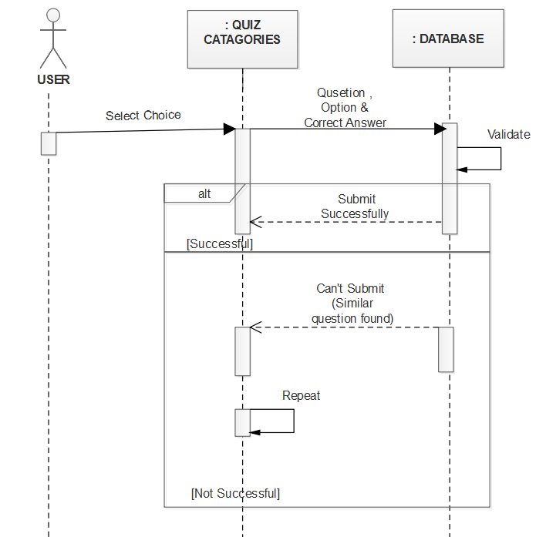

Fig : 3.3.3 Sequence Diagram for Submit Question

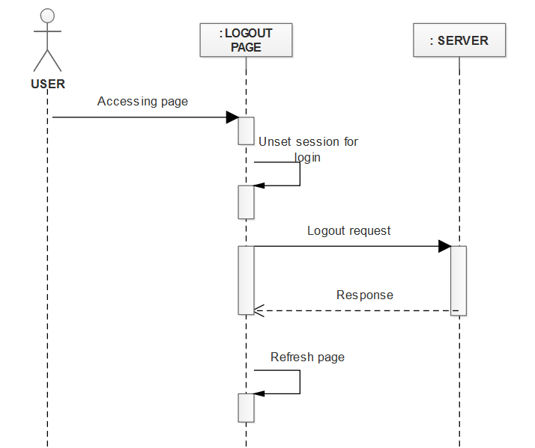

Fig : 3.3.4 Sequence Diagram For Logout

**3.4 ACTIVITY DIAGRAM**

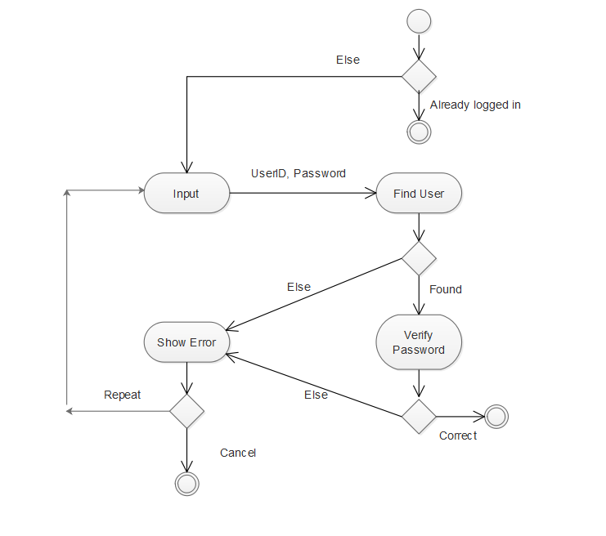Fig : 3.4.1Activity diagram for Login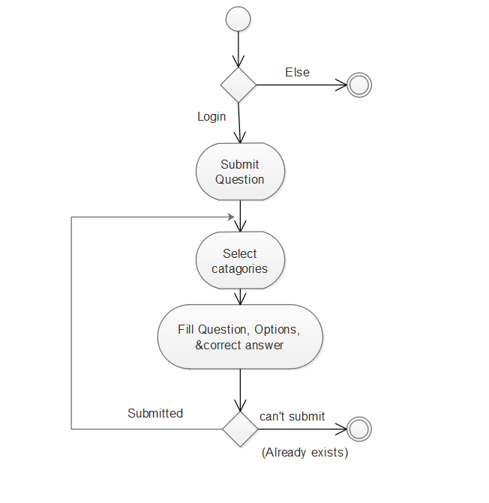 Fig: 3.4.2 Activity Diagram For Submit Quiz

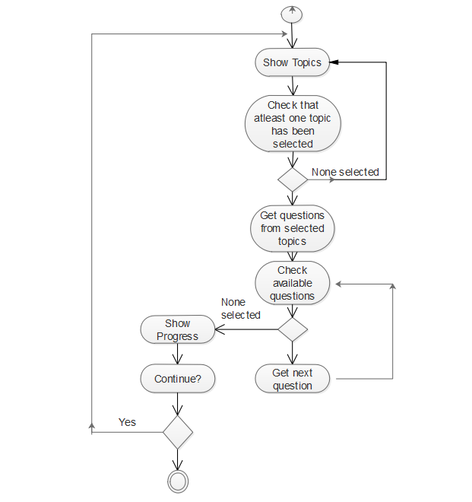Fig : 3.4.3 Activity Diagram For Play quiz

**3.5 CLASS DIAGRAM**

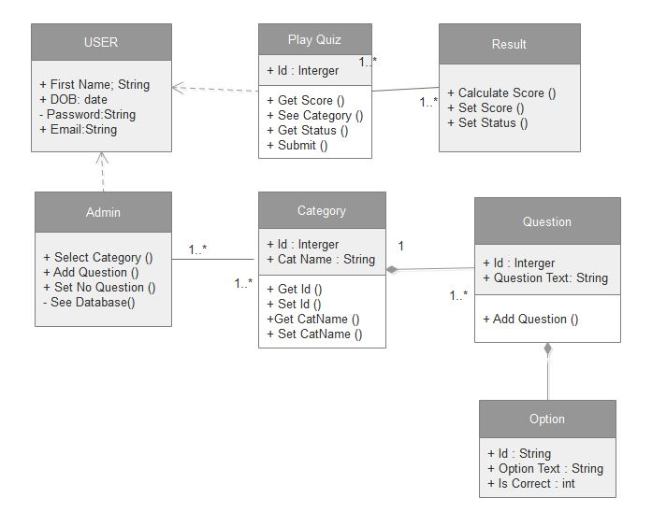

Fig: 3.5.1 Class Diagram for quiz Application

**3.6 Data flow diagram**

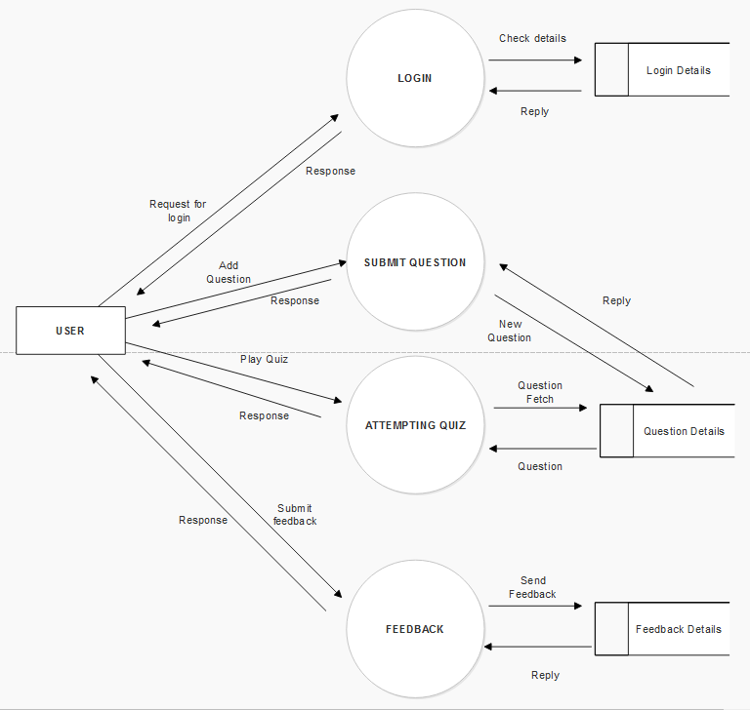

Fig: 3.6.1 Data Flow Diagram For Quiz Application

1. **DESIGN**
   1. **Architectural Design**

**4.1.1 System Architectural Design**

Three-tier architecture is a client- server software architecture pattern in which the use interface (presentation), functional process logic (“business rules”), computer data storage and data access are developed and maintained as independent modules , most often on separate platform.

Apart from the usual advantages of modular software with well-define interface , the Three- tier architecture is intended to allow any of the three – tier to be upgraded or replace independently in response to changes in requirements or technology . For example, a change of operating system in the presentation tier would only affect the use of interface code.

Typically, the user interface runs on a desktop pc or workstations and uses a standard graphical user interface functional process logic that may consist of one or more separate modules running on workstations on application server, and RDBMS on a database server or mainframe that contains the computer data storage logic. The middle tier may be multi-tiered itself (in which case the overall architecture is called an “n-tier architecture”).

**4.1.2 Description of Architectural Diagram**

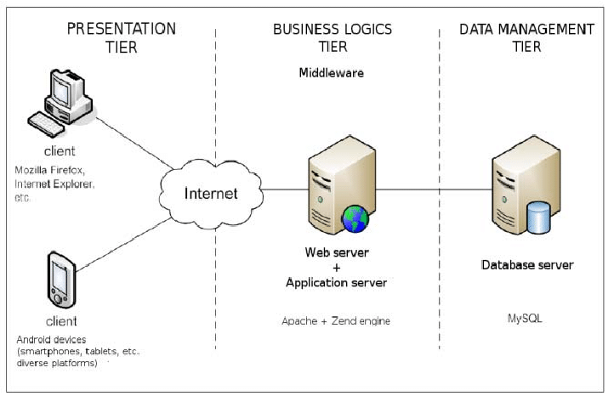

Fig: 4.1.2.1 A 3-Tier Architecture Diagram

**Presentation tier**

This is the top most level of the application .The presentation layer provides the applications user interface .Typically, this involves the use of GUI for smart client interaction, and web based technologies for browser-based interaction. The presentation tier displays information related to such services as browsing, merchandise, purchasing, and cart contents.

**Logic tier (called also business logic, data access tier, or middle tier)**

The logic tier is pulled out from the presentation tier and, as its on layer it controls an application functionalities by performing detailed processing .Logic tier mission – critical business problems are solved. The component that makes up this layer can exist on server machine, to assist in resource sharing. These components can be used to enforce business rules, such as business algorithms and legal or governmental regulations, and data rules which are designed to keep the data structures consistent within either specific or multiple databases.

**Data tier**

This tier consist of data base server , is the actual DBMS access layer .It can be accessed through the business services layer and on occasion by the user services layer. Here information is stored and retrieved. This tier keeps data natural and independent from application server or business logic. Giving data is on tier also improves scalability and performance .This layer consist of data access component to aid in resources sharing and to allow clients to be configured without installing the DBMS libraries and ODBC drivers on each client.

* 1. **Database Design**

**4.2.1 Normalization**

Database normalization is a technique of organizing the data in the database. Normalization is systematic approach decomposing table to eliminate data redundancy an undesirable characteristics like insertion, update and deletions Anomalies. Ti is a multi state process that puts data into tabular form by removing duplicated data from the relation tables.

Normalization is used for mainly two purposes:

* Eliminating redundant data.
* Ensuring data dependence makes sense i.e. data is logically stored.

Our table in the database is in 1 NF form. A table is said to be in 1 NF if both the following conditions hold:

A relation will be 1 NF if it contains an atomic value. It states that an attributes of a table cannot hold multiple values. It must hold single valued attributed. 1 NF disallows the multi-valued attribute, composite attribute, and their combinations.

|  |
| --- |
| Name |
| Password |
| Email id |
| Mobile no. |
| Address |
| DOB |

Fig:4.2.1.1 Database Table

**4.3 Component Diagram**

* + 1. **Flow chart**

A flow chart is a type of a diagram that represents an algorithm, workflow or process, showing the steps as boxes of various kinds, and there order by connecting them with arrows. This diagrammatic representation illustrates a solution model to a given problem. Flow charts are used in analyzing, designing, documenting or managing a process program in a various field.

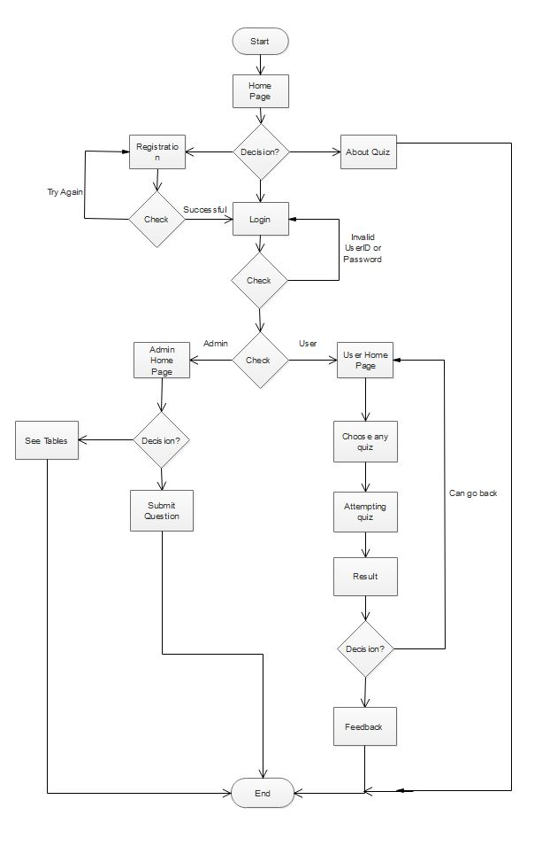

Fig:4.3.1.1 Flowchart

* 1. **Interface Design**

User interface is the front-end application view to which user interacts in order to use the software. User can manipulate and control the software as well as hardware by means of user interface.

UI can be graphical, text based, audio-video based, depending upon the under lying hardware and software combination. UI can be hardware or software or a combination of both.

* + 1. **Screen Shots**

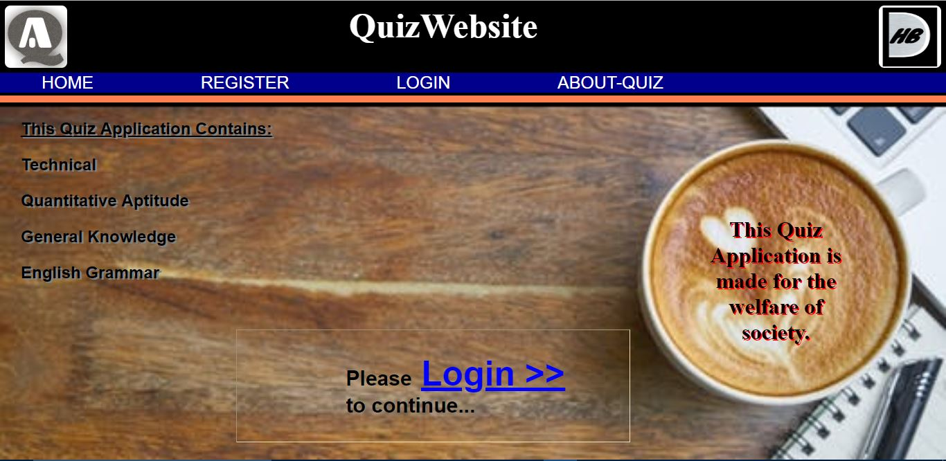

Fig: 4.4.1.1 Home Page



**`** Fig: 4.4.1.2About Quiz Page



Fig: 4.4.1.3 Registration Page



Fig: 4.4.1.4Login Page

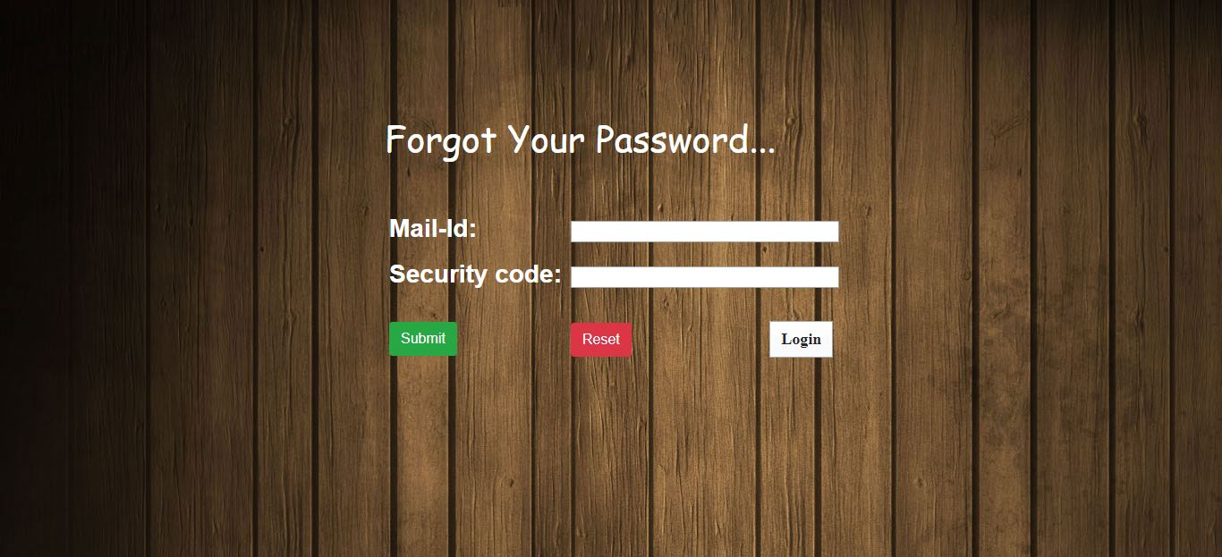

Fig:4.4.1.5 Forgot Password

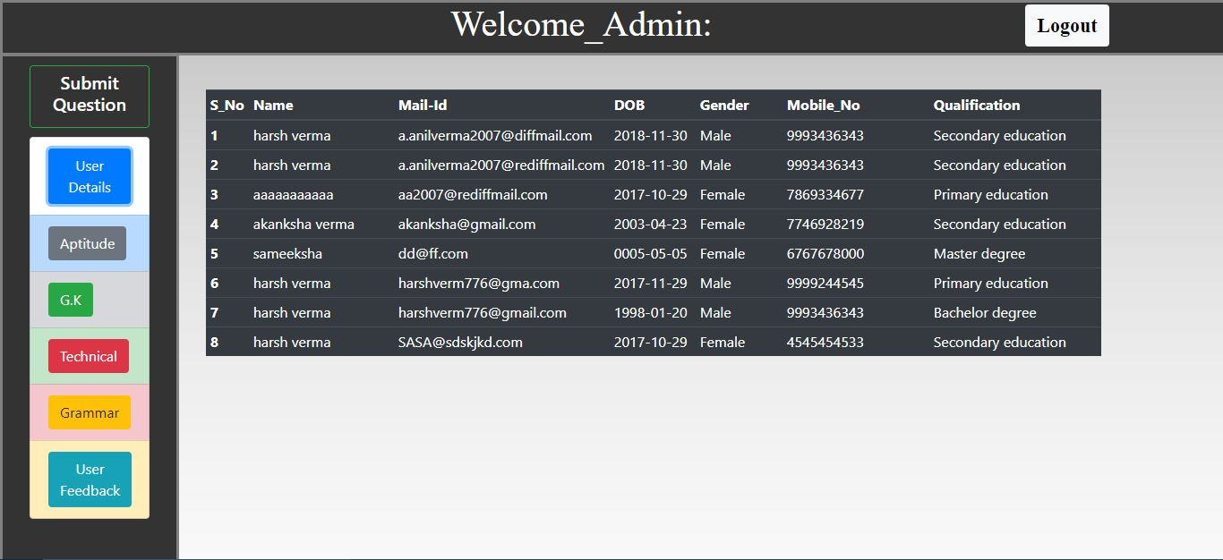

Fig: 4.4.1.6 Admin Page

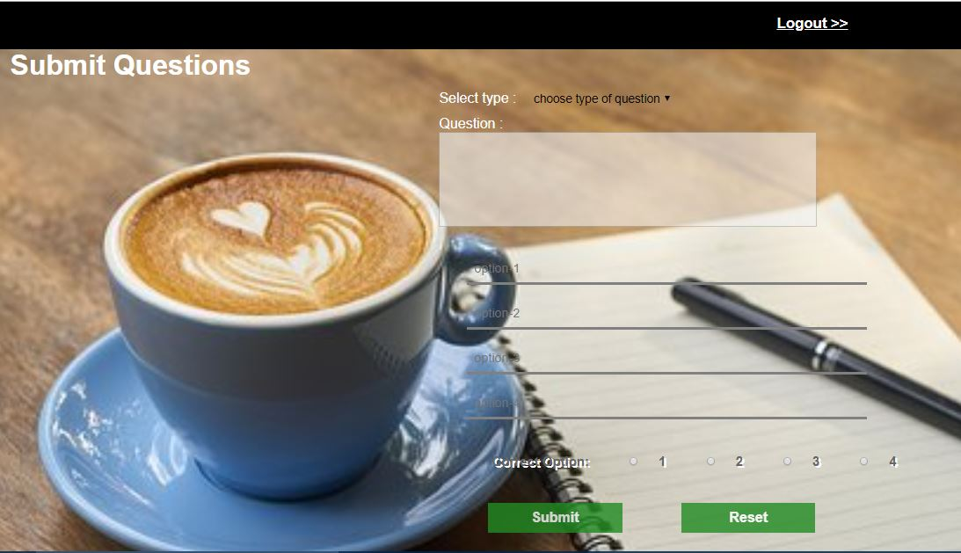

Fig: 4.4.1.7 Submit Question Page

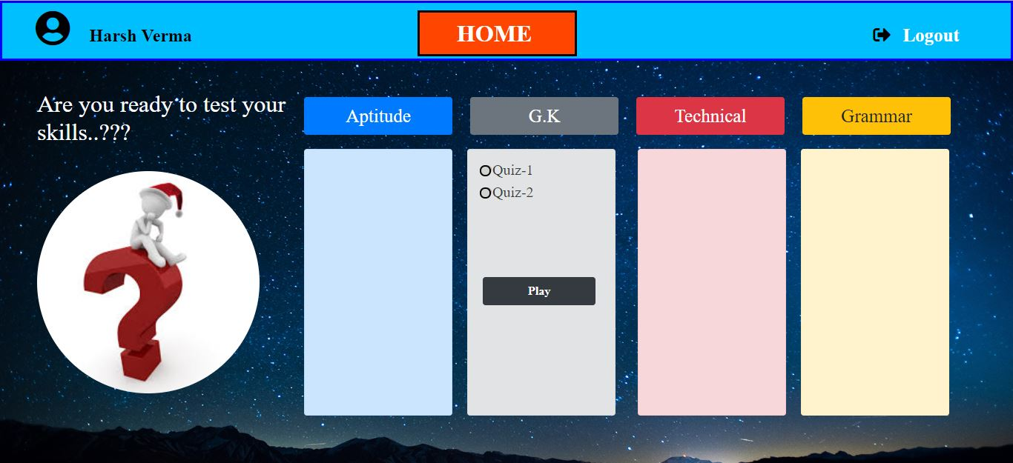

Fig: 4.4.1.8 User Home Page

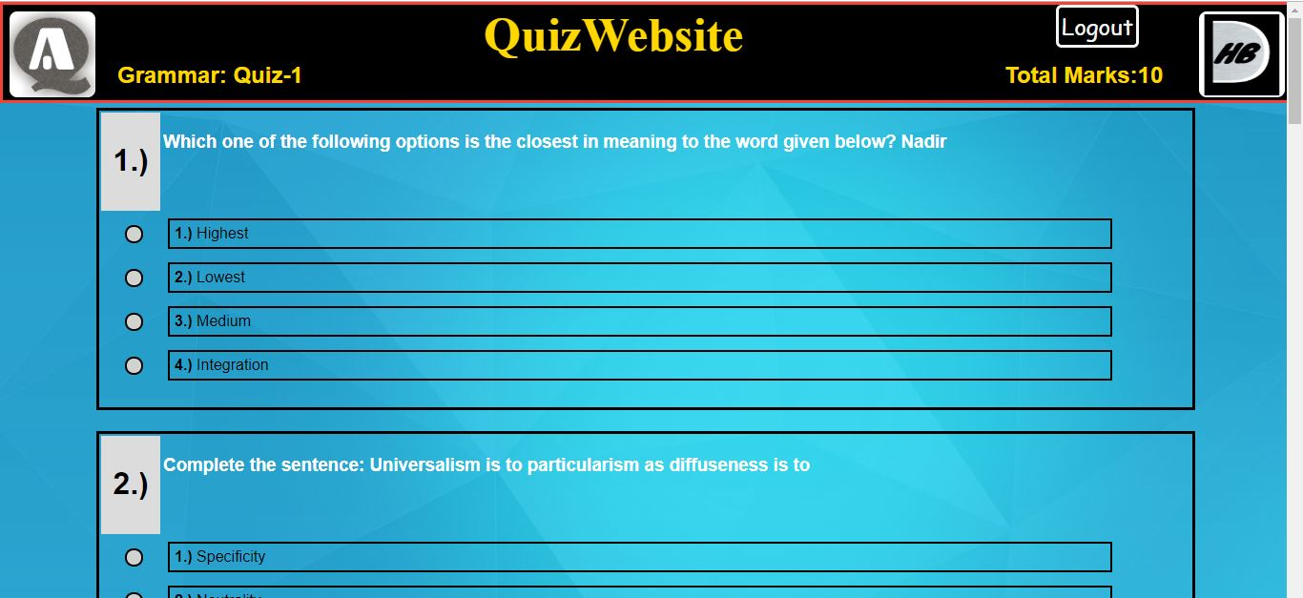

Fig: 4.4.1.9 Attempting Quiz Page

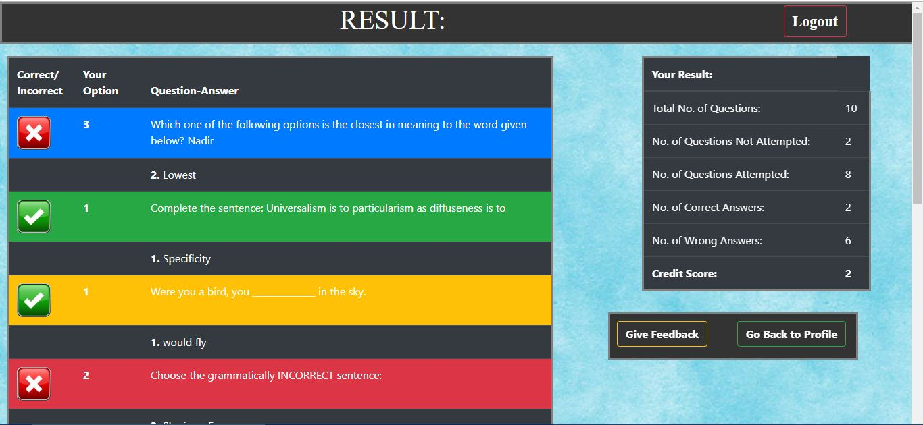

Fig: 4.4.1.10 Result Page

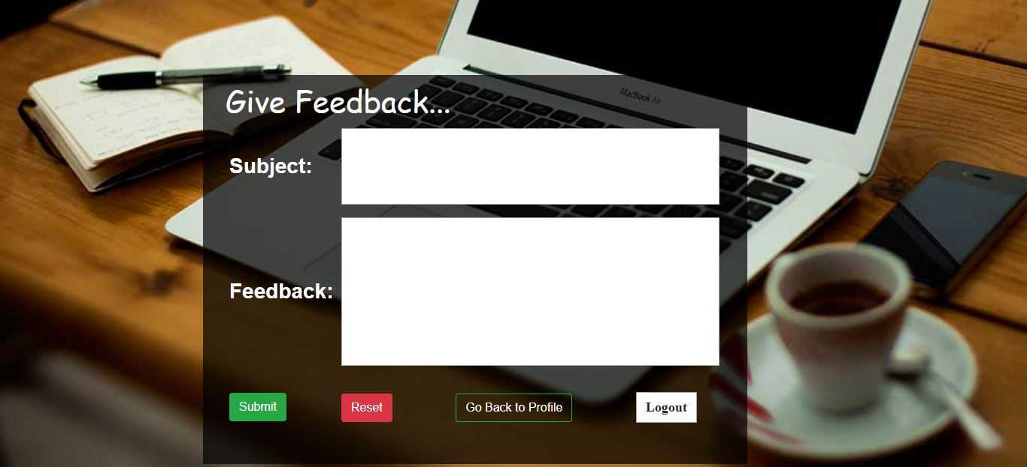

Fig: 4.4.1.11 Feedback Page

1. **Implementation**
   1. **Language And Database Used For The Implementation**

* For the frontend development of the a fore mentioned project:

HTML 5,CSS , JavaScript and Bootstrap has used.

* For the backend development of the a fore mentioned project:
* Java i.e., the .jsp pages are used.
* For the Database Management of the a fore mentioned project:
* MySql is used.
  1. **Feature Of language & database used for the project**
* **HTML:** Widely used for creating web page & pioneer in web application development.
* **My-SQL:** Single & integrated environment, Analysis Services, Reporting Services Supports, Administrative Tasks.

**5.3 Description Of Third Party tools used**

* An IDE, called Netbeans using Glass fish server.
* For the designing phase, UML Diagram maker from Draw.io.
* For CSS , bootstrap.

**6 TESTING**

* 1. **White Box Testing**

White box testing is defined as the testing of software solution’s internal structure, design, and coding. In this type of testing, the code is visible to the tester. It focuses primarily on verifying the flow of inputs and outputs through the application, improving design and usability, strengthening security. White box testing is also called Clear testing, Open Box Testing, Structural testing, Transparent Testing, Code-Based Testing and Glass Box Testing.

**Test Cases of White Box Testing**

* **Test Case Name**: Registration

**Input**: Enter name, dob mail-id, mobile no.,

**Outcomes:** Successfully register. **Expected Outcomes:** Successfully register.

**Result:** Pass.

* **Test Case Name**: Login.

**Input**: Enter Username correct, password correct.

**Outcomes:** login successful. **Expected Outcomes:** login successful

**Result:** Pass.

* **Test Case Name**: Login.

**Input**: Enter Username correct, password wrong.

**Outcomes:** login fail. **Expected Outcomes:** login fail.

**Result:** Fail.

* **Test Case Name**: Login.

**Input**: Enter Username null, password null.

**Outcomes:** login fail. **Expected Outcomes:** login fail.

**Result:** fail.

* 1. **Black box Testing**

Black box testing is also known as Behavioral Testing, is a software testing method in which the internal structure/design/implementation of the item being tested is not known to the tester. These tests can be functional or non-functional, through usually functional.

This method is named so because the software program, in the eyes of the tester, is like a black box; inside which one cannot

See.

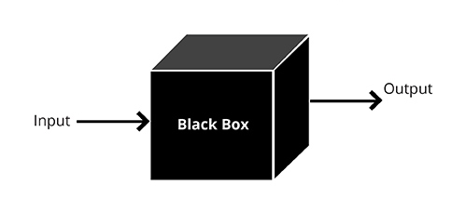

Fig: 6.2.1 Black Box Testing

**Test cases of Black Box Testing**

* **Test Case Name**: Registration.

**Input**: Enter required details for registration.

**Outcomes:** Registered successfully. **Expected Outcomes:** Registered successfully.

**Result:** Pass.

* **Test Case Name**: Registration.

**Input**: Enter required details for registration.

**Outcomes:** Validation not correct. **Expected Outcomes:** Registered not successfully.

**Result :** Fail.

1. **FUTURE SCOPE AND LIMITATION**

**Scope:-**

**The Scope of this project is very broad in terms of gaining knowledge and sharing knowledge among world.**

Few points are:-

* Can be used anywhere any time as it is a web based application.
* This application will be used in educational institutions as well as in corporate world.

**Limitation:-**

* We want to implement a concept where user itself can add question for others.
* We want to implement a concept where the user can solve any query related to each question at that time only.
* We also want to implement a concept where every user can see profile of other user.

1. **CONCLUSION**

This online quiz application provides facility to play quiz anywhere and anytime. It save time since user does need to wait for result. So student/user cannot wait for the result. All Student/ user get extra knowledge and skills. Administrator has a privilege to put as much as question in any category given in application. User can register, log-in, and give the test with his/her specific id, and can see the results as well.

1. **REFERENCE**

* https://www.W3schools.com/
* https://stackoverflow.com/
* https://www.quora.com/
* https://www.draw.io/